MAN 8.3.1 EVAN Toolbox
Node User Reference Manual

Youssef Shady George-Nashed, Vincent Dalge,
Helgi Gunnarsson, Roger Phillips and Paul O’Higgins

The University of Hull
University of York

Version 1.1 – 24th March 2010

Creating software for the future of anthropology.



 | 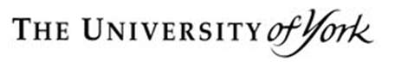

EVAN Toolbox Node User Reference Manual

Contents
1. Introduction 1
2. Catalogue of node specifications 1
2.1 Data nodes 1
a) Node: Import (last updated 24 March 2010) 2
b) Node: Export (last updated 24 March 2010) 7
c) Node: select 10
d) Node: Reflected Relabelling (last updated 24 March 2010) 13
e) Node: Templand 14
2.2 GMM nodes 15
f) Node: GPA – Procrustes (last updated 24 March 2010) 16
g) Node: PCA (last updated 24 March 2010) 19
h) Node: PLS (two block) (last updated 24 March 2010) 21
i) Node: Regression (last updated 24 March 2010) 23
j) Node: Principal Coordinates Analysis 25
k) Node: Generate Surface 26
2.3 View nodes 31
l) Node: 3D Viewer 32
m) Node: Graph Plotter 34
2.4 Utility nodes 37
n) Node: group 38
o) Node: subtract (last updated 24 March 2010) 41
p) Node: concat 42
q) Node: transform 43
s) Node: R 44

EVAN Toolbox Node User Reference Manual

1. Introduction

This manual provides a catalogue of nodes that are available in the EVAN Toolbox.

The nodes are arranged as Data, GMM, View and Utility nodes.

For each node its function is explained, its input and export ports are explained and if the node has a GUI then its user interface is explained.

2. Catalogue of node specifications

2.1 Data nodes

a) Node: Import (last updated 24 March 2010)
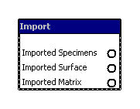
This node allows the user to import into the Toolbox specimens, surfaces and matrices and it makes these available on its output ports, namely: Imported Specimens, Imported Surface and Imported Matrix.

The user interface has 4 tabs, one for each type of import as shown in Figure 1.

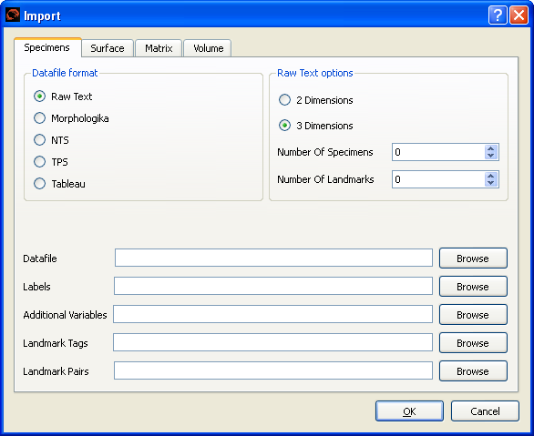

Figure 1 Current GUI of import node (Specimens tab)

Specimens tab

The user parameters for this tab are as follows.
Datafile: Filename of file containing landmarks of a number of specimens.
Labels: Filename of file containing the user specified identification labels for the specimens.
Additional Variables: Filename of file containing additional (i.e non landmark) variables associated with each of the specimens. Typically these additional specimen variables are used in other nodes to select subsets of specimens for visualization / analysis purposes.
Landmark Tags: NOT YET IMPLEMENTED. Filename of file containing a number of descriptor variables for each the of landmarks.
Landmark Pairs: Filename of file containing a list of landmarks that are paired together.

The Specimens tab options cater for reading in the landmark variables and additional variables for a number of specimens from file(s) of predetermined format and places this data on an output port as specimens. It can also read in the identifying labels for the specimens. It can also read in the descriptor variables for landmarks (NOT YET IMPLEMENTED). All the imports that are provided by the user appear on the Imported specimens output port.

The “Additional Variables“ and the “Landmark“ descriptor variables can be integers, real numbers, strings or booleans.

This node supports the following input landmark file formats:
raw text – here the user must specify the dimensionality of the data in the Raw Text options panel of the GUI for this tab. A raw text file contains just the values in dimension, landmark and specimen order.
NTS
TPS
Morphologika
Tableau (this is the format used in Templand)

If the landmark file format is capable of representing additional specimen variables, specimen labels or landmark descriptor variables then the user must provides these variables in this landmark file rather than use the import file options for them.

Surface tab

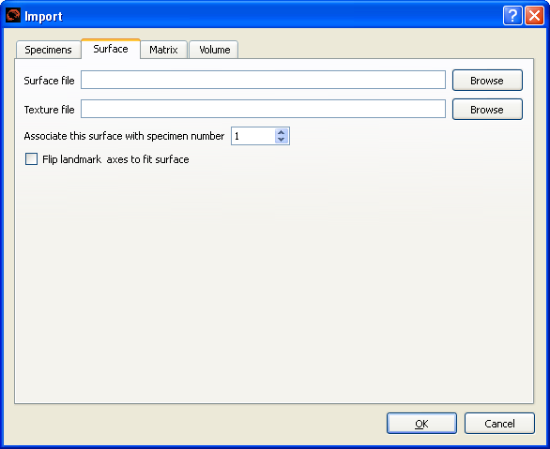

Figure 2 Current GUI of import node (Surface tab)

The user parameters for this tab are as follows.
Surface file: Filename of the file containing the vertices, polygons, etc of a single surface for a single specimen.
Texture file: Filename of the file containing the texture for the above surface for a single specimen. This parameter is optional.

This node reads in the surface and optionally a texture for a specimen and places them both on its Imported Surfaces output port.

A surface can be associated with a set of landmarks. The surface can then be transformed in the GPA node according to the transformation matrix of this associated landmark set. By default the surface is associated with the first landmark set in the datafile.

When importing a surface, the axes are sometimes flipped in the process. We have a checkbox to correct for this.

The surface file can be in the following formats:
3D Studio (3DS)
LightWave Object (LWO)
LightWave 3D Scene (LWS)
MD2 (MD2)
MDL (MDL)
OpenSceneGraph (OSG)
WaveFront (OBJ)
Polygon (PLY)
Stereolithography (STL)
Edgewarp (SUR)

The surface file can also be a Morphologika file, in which case the polygons are matched to the first specimen in the file and set as a surface.

The texture file can be in the following formats:
Windows Bitmap (BMP)
Portable Network Graphics (PNG)
Joint Photographics Expert Groups (JPG)

Matrix tab

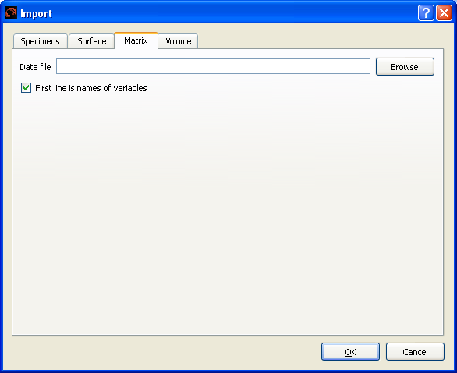

Figure 3 Current GUI of import node (Matrix tab)

The user parameters for this tab are as follows.
Data file: this is the Filename of the file containing the matrix to be imported. The first line of the file may optionally be used to specify the column names for the imported matrix.

Data is read from the user specified text file and placed on the Imported matrix output port. This node can be used for importing matrix data, thus it allows the import of data that is not in any of the prescribed specimen formats.

Volume tab

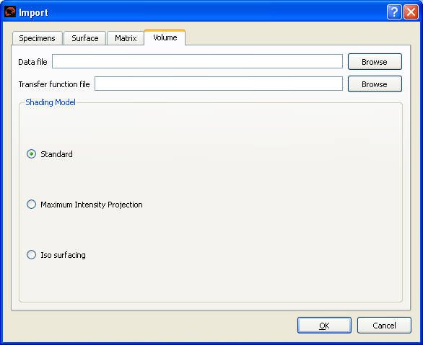
Figure 4 Current GUI of Import node (Volume tab)

There is a tab for importing volumes. It is still in early stages of development but it is possible to import some Dicom formats.

b) Node: Export (last updated 24 March 2010)

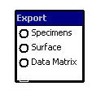
This nodes allows the writing out of specimens data to the output file in the specified format supplied by its input ports, namely: Specimens, Surface and Data Matrix.

The user interface for this node has 3 tabs, one for each type of export.

Specimens tab

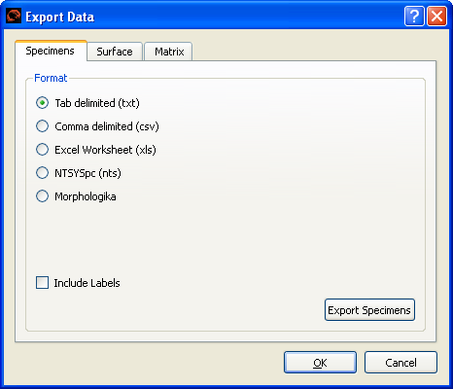

Figure 5 Current GUI of Export node (Specimens tab)

In this tab the user specifies the file format for saving the specimens data to be exported. The allowed formats are
- Tab delimeted
- Comma delimited
- Excel spreadsheet
- NTSYSpc
- Morphologika

If the Include Labels checkbox is checked, then labels for the rows and columns are added to the exported data. The row labels are the specimen names and the column labels are the names of variables.

When the Export Specimens button is clicked, a File Dialog appears and user can specify the name of the file to which the exported specimens data will be saved.

Surface tab

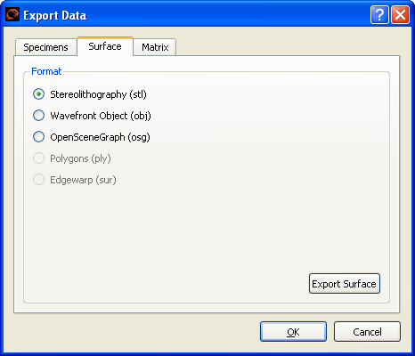

Figure 6 Current GUI of the export node (Surface tab)

In this tab the user specifies the file format for saving the surface data to be exported. The user can select between 3 different formats, namely:
STL, OBJ or OSG.

When the Export Surface button is clicked, a File Dialog appears and user can specify the name of the file to which the exported surface data will be saved.

Matrix tab

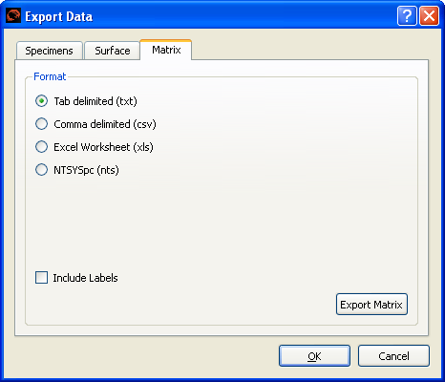

Figure 7 Current GUI of the export node (Matrix tab)

This tab caters for exporting data matrices from the network. For exporting specimens then the Specimens tab should be used.

In this tab the user specifies the file format for saving the surface data to be exported. The user can select between 4 different formats, namely:
Text, CSV, Excel worksheet or NTSYSpc

If the Include Labels checkbox is checked, then labels for the rows and columns are added to the exported data. The row labels are the specimen names and the column labels are the names of variables.

When the Export Matrix button is clicked, a File Dialog appears and the user can specify the name of the file to which the exported matrix data will be saved.

c) Node: select

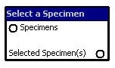
This node allows the user to select specimens from the Specimens input port and places the selected specimens on its Selected Specimen(s) output port. Furthermore, this node allows the user to remove landmarks for all the selected specimens; this is useful if there is missing or erronous landmark data.

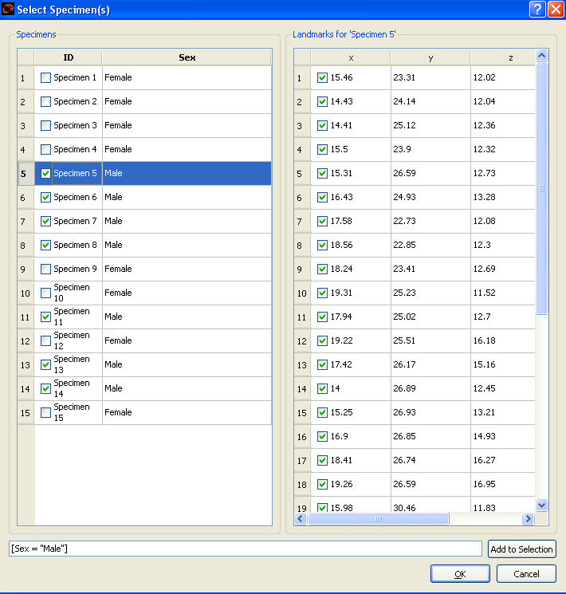

Figure 7 GUI of select node

In the user parameter GUI above for this node, the user specifies the subset of specimens and the subset of landmarks that are to be selected and sent to the Selected Specimen(s) output port. The user is presented with a spreadsheet like interface showing the specimens label, landmarks and additional variables for the specimens. In the spreadsheet missing landmark data is highlighted.

Specimens can be selected in the following ways:
- Direct selection, i.e. by ticking on the spreadsheet the checkbox for each speciment to be selected.
- By typing in a set expression that specifies the members of a set of specimens that are to be selected. When the Add to Selection button is pressed then specimens selected will appear with a tick in their checkbox. Set expression can refer to additional variables of specimens as well as the labels of specimens.

Landmarks can be removed in the following ways:
- By directly unchecking landmarks from the spreadsheet

The spreadsheet highlights any missing data for the landmarks or additional variables.

A set expression comprises an expression of set member operands. These operands can then be combined together using the set operators “+“ (add sets), “-“ (set subtraction) and “&“ (set union). A set member operand is given by enclosing it in [ .. ]. Within the [ ..] a select members expression is specified. This can take one of 4 following forms.

- [ ] represents an empty set.
- [ALL] represents a set with all specimens as members.
- [MISSING] represents a set of specimen members that have missing landmark data.
- Select expression: this allows members to be selected by specifiying selection conditions on specimens identifying label and their environmental variables,
e.g. Sex = “Male“,
in such terms the relational operators =, !=, >, <, >= and =< with there obvious meaning are permitted. Such relational terms can then be combined using the logical operators AND and OR,
e.g. Sex = “male“ AND age > 16.
These logical sub-expressions can be inverted by enclosing the expression in ( ) and preceding it with the logical operator NOT,
e.g. NOT (Sex = “male“ AND age > 16).
Set members can also be selected individually by their identifying label name,
e.g. [ID = “Specimen 7“]

The user types in a set expression at the bottom of the GUI and then presses the Add to Selection button.

This next bit is a formal description of the syntax and can be ignored by most readers. Its provided here mainly as documentation for the development team.

The syntax of set expressions currently implemented is as follows.

<set expr> = <set oprnd> { <set opr> <set expr> }
<set opr> = “+“ | “-“ | “&“
<set oprnd> = “[ ]“ | “[ALL]“ | “[MISSING]“ | “[“<select expr>“]“
<select expr> = <select factor> { <log opr> <select expr> }
<select factor> = “(“ <select expr> “)“ | “NOT “ <select factor> |
<term> <rel opr> <term> | <term>
<log opr> = “ AND “ | “ OR “
<rel opr> = “<“ | “>“ | “=<“ | “>=“ | “=“ | “!=“

<term> = name | constant

d) Node: Reflected Relabelling (last updated 24 March 2010)

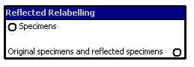

For each landmark set on its Specimens input port, this node creates a new set that is a reflection of the original with paired landmarks swapped. It then places them both on its Original specimens and reflected specimens output port. The number of output specimens is twice the number of input specimens.
A file containing a list of which landmarks are paired together must be set in the Import node.

e) Node: Templand
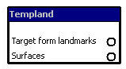

This is the landmarking node. Currently it has the ability to place landmarks on surfaces. Documentation for this node will be provided shortly.

2.2 GMM nodes

f) Node: GPA – Procrustes (last updated 24 March 2010)

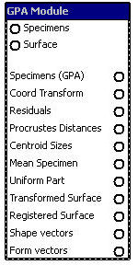

This node performs a GPA (General Procrustes Analysis) on the input specimens provided on its Specimens input port taking into account the parameters specified by the user in GUI below. Further information on GPA can be found elsewhere. It makes the results of the GPA available via its output ports which are summarised below. If a surface is provided on the node‘s Surface input port then this node creates a corresponding surface in GPA space on its Transformed Surface output port.

Specimens (GPA) with landmarks of all specimens in GPA space
Coord Transform: provides the transform matrices for all specimens that give the transformation between their initial coordinate space to GPA space
Residuals of all specimens
ProcrustesDistances between all pairs of specimens
Centroid Sizes sizes of all specimens
Mean Specimen: landmark set of the Mean specimen in GPA space
Uniform Part of the transformation
Transformed Surface: surface in GPA space
Registered Surface - surface warped to the mean specimen
Shape vectors – procrustes coordinates in matrix form
Form vectors - shape vectors plus a column of ln centroid sizes

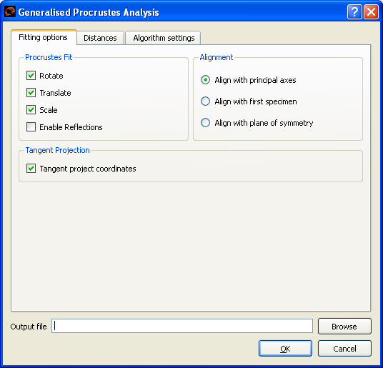
Figure 8 GUI of GPA node

The above GUI for this node allows the user to set the following parameters for the GPA.
Procrustes Fit:
There are options to translate, scale, rotate and enable reflections.
The default is to translate, scale, rotate and enable reflections.

Alignment:
This specifies the coordinate system to be used for the procrustes mean, procrustes coordinates and residuals.
Permitted values are:
0: align coordinates with the principal axes.
1: align coordinates with the first specimen.
2: align coordinates with the plane of symmetry.
The default is to align with principal axes.

Tangent Projection:
There is an option to do tangent plane projection on the coordinates.

Distances Between Specimens:
There are a number of different options for calculating distances between specimens.
First, the user can choose between pairwise distances or not. If pairwise, then the specimens are compared two and two at a time and rotated to minimize the distance. Otherwise the distance is calculated directly from GPA fitted specimens.

GPA fitted:
Euclidean distances
Tangent distances

Pairwise:
Full procrustes distances (Df)
Partial procrustes distances (Dp)
Procrustes distances (ρ)

The default is to use euclidean distances, i.e. the sum of squared differences of the procrustes residuals.

There is also an option of calculating form space distances. Form space distance squared is the square of the natural logarithm of the ratio of centroid sizes plus the square of the procrustes distance.

If an output file is specified in the output file field, then a text file with output is created.

g) Node: PCA (last updated 24 March 2010)

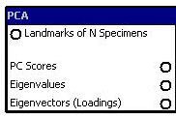

This node performs a Principal Component Analysis on the specimens provided by its Landmarks of N Specimens input port and and makes available the PCA results via its ouput ports, namely PC Scores, Eigenvalues and Eigenvectors (Loadings).

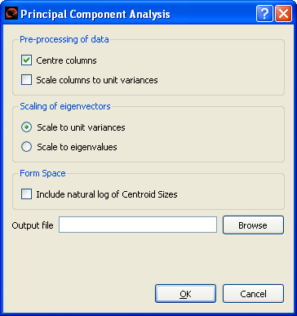
Figure 9 GUI for Principal Component Analysis Node

The above GUI for this node allows the user to set the following parameters for the PCA.
The Pre-processing of data panel of the GUI provides options to centre and scale data prior to calculating. If the Center columns tick box is checked, the variables are scaled to unit variances, otherwise they are scaled to unit sums of squares.

The Scaling of Eigenvectors panel of the GUI provides options to scale eigenvectors so that variance is equal to the eigenvalues or to scale them to unit size.

If the Form space (include Ln of centroid Sizes) check box is ticked then
an extra column of natural log of centroid sizes is added to the data before PCA is applied. Centroid sizes are stored in with specimens data, thus this option should only be selected where the nodes input is of this datatype.

If an output file is specified in the output file field, then a text file with output is created.

h) Node: PLS (two block) (last updated 24 March 2010)

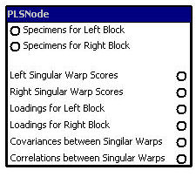
This node performs a Two Block Partial Least Squares Analysis on the two input blocks of provided on its Specimens for Left Block and its Specimens for Right Block input ports. The various results of this PLS analysis then appear on the nodes output ports, namely Left / Right Singular Warp Scores, Loadings for Left / Right Block, Covariances between Singular Warps and Correlations between Singular Warps.

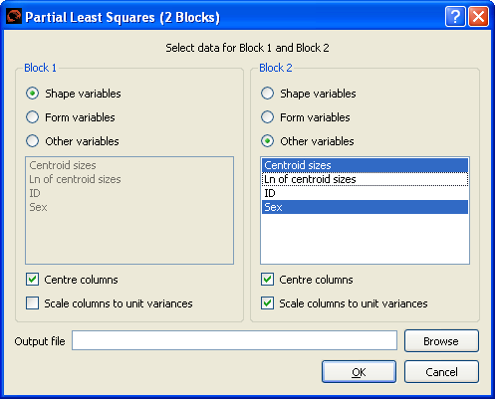

Figure 10 GUI of the two block PLS node

The above GUI for this node allows the user to set parameters for the PLS analysis.

The GUI allows the user to select the type of input variables for both the left and right blocks. These can be:
Shape variables
Form variables
Other variables, here the user selects the variables for analysis from the panel of variables.

The user also has options to centre and/or scale the variables. If centred, the variables are scaled to unit variances, otherwise they are scaled to unit sums of squares.

If form variables are selected, then a column of the natural logarithm of centroid sizes is added to the shape coordinates.

i) Node: Regression (last updated 24 March 2010)

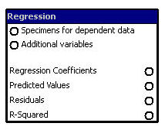

This node performs a Multivariate Multiple Regression analysis on the selected dependent and independent variables provided respectively by its Specimens for dependent data and Additional variables input ports. The results of the analysis are placed on the nodes output ports, namely: Regression Coefficients (matrix output), Predicted Values (matrix), Residuals (matrix) and R-Squared (vector).

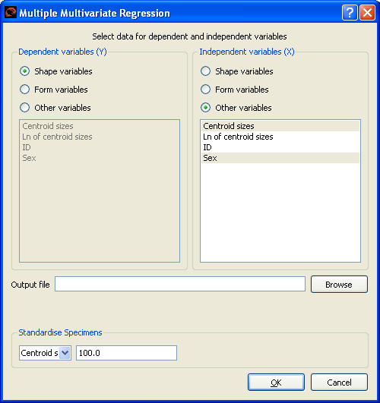

Figure 11 GUI for regression node

The above GUI for this node allows the user to set the type of variables for both the Dependent variables (Y) and the Independent variables (X) for the regression analysis.
These can be:
Shape variables
Form variables
Other variables, here the user selects the variables for analysis from the panel of variables.

If form variables are selected, then a column of the natural logarithm of centroid sizes is added to the shape coordinates.

If an output file is specified in the output file field, then a text file with output is created.

There is also an option to select one variable and standardise all specimen to the same value of that variable.

j) Node: Principal Coordinates Analysis

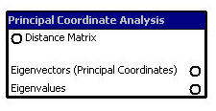

This node performs a Principal Coordinates Analysis on a symmetric matrix of distances provided by its Distance Matrix input port. It places the results of this analysis on its output ports, namely: Eigenvectors (Principal Coordinates) (a matrix) and Eigenvalues (a vector).

The Distance Matrix provided must be symmetric, otherwise this node returns an error when this node runs.

k) Node: Generate Surface

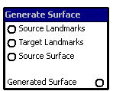

This node is typically used to create a surface for a landmark set that has no surface or to produce a surface for a mean specimen. This node warps the surface geometry provided by the Source Surface input port and places the computed warped surface on its Generated Surface output port. The surface is warped from a source landmark configuration to a target landmark configuration provided, respectively, by the nodes Source Landmarks and Target Landmarks input ports. This node uses a Thin Plate Spline algorithm for the warping.

l) Node: warper

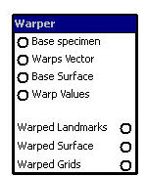

This node allows the user to warp a specimen from its base landmark configuration provided by its Base specimen input port along one or more direction vectors for warping given by the node‘s Warps Vector input port. The resulting warped set of landmarks is placed on the node‘s Warped Landmarks output port.

If a surface is provided for the base specimen on the node‘s Base Surface input port then this too will be warped and the resulting warped surface is placed on the node‘s Warped Surface output port.

This amount of warping is controllable by the GUI of this node, in addition and optionally other nodes in the network (e.g. the plot node) may control the warping by sending Warp Values to the input port of this node.

This nodes also allows the user to create one or more wireframe grids which the user places in the region of interest of the warp. As warping is applied then these grids deform to show the effect of warping. The GUI for this node caters for the creation and deletion of grids. Any grids created are placed on the node‘s Warped Grids output port.

This node implements warping using a Thin Plate Spline algorithm.

The GUI for this node has two tabs, namely Warping and Grid(s).

Warping tab

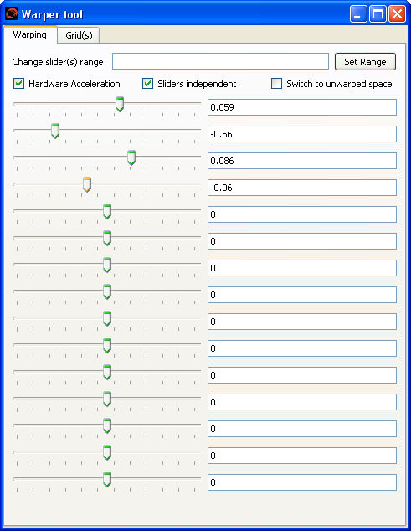

Figure 12 Warping tab: GUI for controlling the warp value

This warping tab provides a slider control for each of the warping direction vectors. A warp value of 0 corresponds to no warping and a warp value of 1 corresponds to the amount of warping given by the warping vector. If warp values have been provided by the nodes Warp Values input port then these controls in the GUI will track the values provided on the port. However, the user may use this node‘s slider controls to override the warp values provided by the input port.

Unticking the Sliders independent check box of the GUI makes all the sliders move together in unison.

The range of the warping values can be changed by typing in the range value in the Change slider(s) range cell and then pressing the Set Range button.

If the Hardware Acceleration check box is ticked then much of the computation for the warp will be performed on the GPU otherwise the computation is performed on the CPU. This greatly speeds up the rendering for surfaces with a high polygon count. However, GPUs we‘ve tested have a limit that they can only cope with a maximum of 4 warp direction vectors. The consequence of this is that for slider 5 and beyond the surface does not warp when these controls are changed.

The Switch to unwarped space check box if ticked resets temporarily all the warp slider control values to zero. Unticking the box reinstates the previous slider control values.

Grid(s) tab

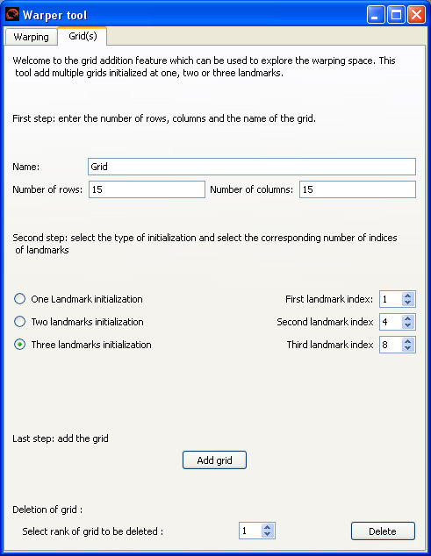

Figure 13 Grid(s) tab: GUI for controlling the grid

This tab allows the user to create grids for the visualization of warping deformation.

For each grid the user via the GUI first specifies the Name of the grid, and the Number of rows and Number of columns in the grid. Next the user specifies the initial position of the grid by giving either one, two or three landmarks. Finally, the grid is created by pressing the Add Grid button. Each grid created will be ouput on the nodes Warped grid output port. Typically these grids are viewed in downstream nodes e.g. the 3DView node which provides controls to manipulate further the grid in terms of its position, orientation and scale.

Grids can be deleted by selecting its number from the Select rank of grid to be deleted cell and pressing the Delete button.

2.3 View nodes

l) Node: 3D Viewer

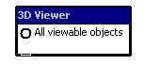
This node produces a graphical display of the renderable objects provided on its All viewable objects input port. Any number of the output ports may be connected to this input port. Renderable objects include of specimens, surfaces and grids (from the warper node).

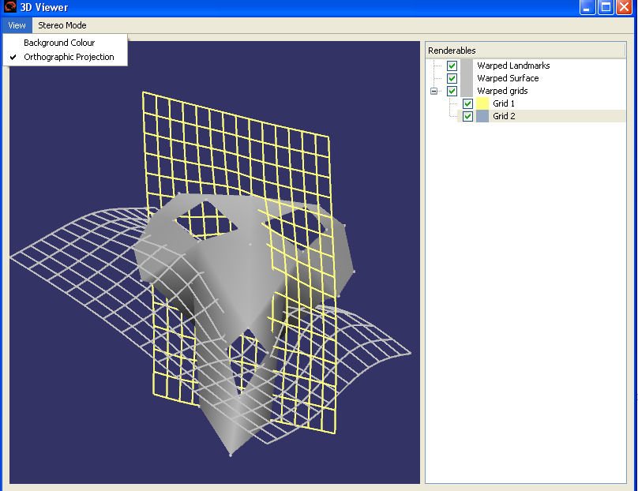

Figure 14 Window of viewer node showing some of the display controls

The View menu of the 3D Viewer window provides options to change the Background Colour of the display panel and to switch between the normal Orthographic Projection for the display and a perspective projection.

The Stereo Mode menu options provides a range of options for providing 3D stereoscopic views in the display panel.

Renderable objects provided by the nodes input port appear as a tree representation on the right hand side of the GUI. Selecting the + and – boxes in the tree view allows the branches of the tree to be expanded and collapsed. The tree shows the substructure of displayable objects. The display of objects can be turned on and off individually or turned on or off at a higher level branch in the tree by use of the check boxes at all nodes of the tree.

To navigate within the window the mouse controls are
- Left mouse button drag to rotate scene
- Vertical right mouse button drag to zoom in and out of the scene
- Middle mouse button (or left and right mouse buttons together) to pan the scene.
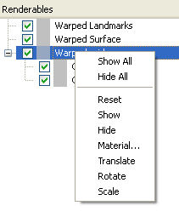
Figure 15 Example of options available for a node of renderables

At each node in the tree (whether branch or leaf) a number of options are provided to control that node. These can be accessed by selecting the node with a right mouse button click to provide a pull down menu of options. This is illustrated in the above figure. In this figure
- Various menu options are provided to hide or show items in the branch.
- The Material menu option allows the colour and transparency of displayable items to be changed.
- The Translate, Rotate and Scale options allow the user to manipulate the item(s) of the node within the scene. For these options a manipulator appears in the scene to control the manipulation. For grids that are subject to warping then as the grid is manipulated the grid will warp correspondingly thus allowing the user to explore eassily warping within a region of interest.

m) Node: Graph Plotter

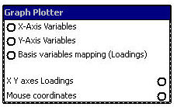

This node provide a general purpose facility for creating a graphical 2D scatter plot in a window. The node‘s input ports X-axis Variables and Y-axis Variables provide one or more sets of corresponding x and y values for the scatter plot. The columns of the data input give alternate sets of X / Y values. The row position within a column gives the item number. The node allows the user to select which two sets (i.e. columns) of values to use for the scatter plot. For example, if a scatter plot of specimens is required of its principal components. The X-axis variables would provide the principal component values for all the specimens. Similarly, for the Y-axis variables. This node would allow the user to choose and then plot for all specimens one particular PC aganist another PC.

This node also allows the plotting area to be used as a 2D control of another node (e.g. the warper node). In which case the position of the cursor in the plot area is provided by this node on its Mouse coordinates output port.

The node‘s input port Basis variables mapping (Loadings) provides loadings associated with all the possible X-axis and Y-axis variables. Depending on which sets of variables are actually selected by the user within this node for the scatter plot, the corresponding loadings for the X-axis and Y-axis are placed on the node‘s XY axes Loadings output port.

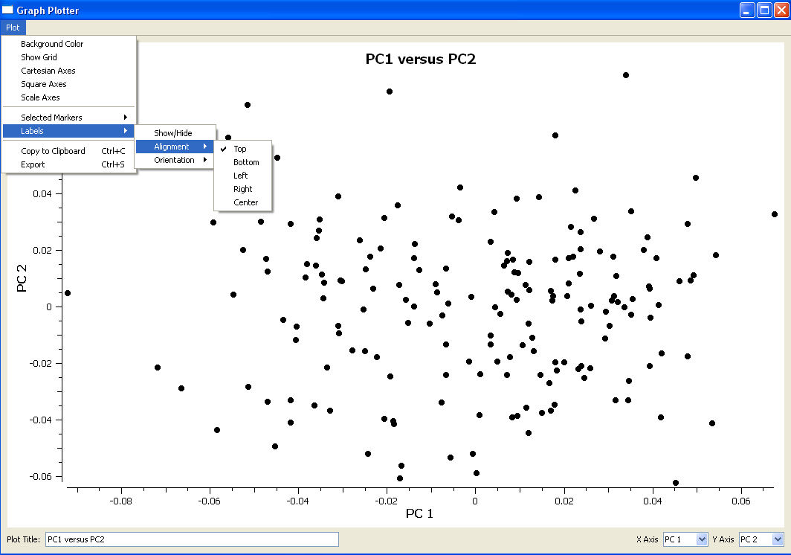

Figure 16 Window of plot node showing some of the menu options

The GUI for this node provides a display area for the 2D scatter plot and various controls.

The bottom left of the GUI provides pull down options for the user to select the two variables for the X Axis and the Y Axis for the scatter plot.

The title of the grid can be specified by the user in the Plot Title cell.

The Plot menu provides the user with following options.
- Background colour: change the background colour of the plot area
- Show grid: turn gridlines on and off in the plot area
- Cartesian Axis: controls display of axis in Cartesian format or in normal format
- Square Axis: controls display axis ranges, a square axis is one in which zero is always the mid point of the displayed axis
- Scale Axis: this allows the user to scale the limits of the axis. This is useful when the plotter node is used as 2D control for the warper node as this allows warping values to be explored beyond the area of the scatter plot.
- Selected Markers: this option allows the user to change the style, colour and size of the plot symbols of the selected markers (i.e. plotted points). These selected markers should have been previously selected by dragging with the left mouse button in the plot area afterwhich all the selected markers turn green (note this is very intuitive and this will be changed ASAP).
- Selected Labels: this option allows the user to control the display of labels in the plot area for selected markers. Options are provided to show or hide labels, change the orientation of labels, change the alignement of label with respect to their plotted point. As with the previous options these selected markers should have been previously selected by dragging with the left mouse button in the plot area afterwhich all the selected markers turn green.
- Copy to Clipboard: this copies the plot area display to the clipboard.
- Export: this produces a high resolution image of the plot area and is saved in a file specified by the user. Such image files are useful for producing publications.

2.4 Utility nodes

n) Node: group
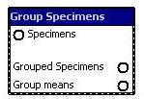

This node allows the user to set up one or more groups of specimens and then to set their default display attributes for these groups, and also to set display attributes for individuals within the group. These display attributes control how the groups are then displayed in downstream viewer nodes such as the 3DView and Graph Plotter nodes.
Specimens can belong to more than one group.

An option is provided to compute a mean specimen for a group which is then added to the group.

The Specimens input port provides the specimens for grouping and the node places the groups on its Grouped Specimens output port.

The node also creates an extra group containing all the means of the groups the user has set up. This extra group is available via the node‘s Group means port

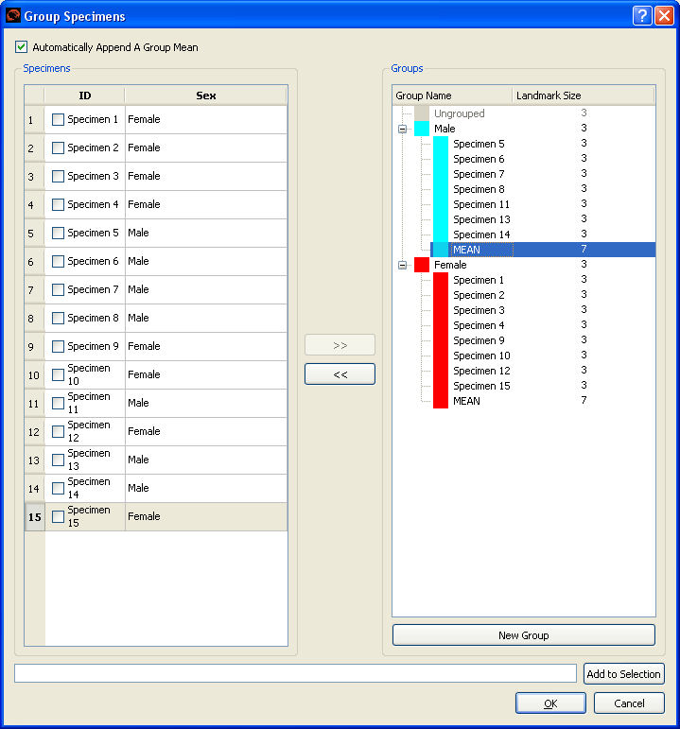

Figure 17 GUI for Group node

The Groups panel of the GUI shows the groups that have been set up and the specimens contained within these groups. This is represented by a tree view. The tree view can be expanded and collapsed by selecting the + and – boxes in the tree.

Typically, a user will first create the groups required, set up theit display properties and then populate each of the groups.

To add a new group, first press the New Group button, at which point a new group will appear in the panel. Double clicking the name with the left mouse button then allows the user to change the name of the group. Clicking the name with the right mouse button allows the user to change the colour and size of display markers for the group. The colour and size of individual specimens may also changed in the same way.

Members of a group are added by using the Specimens panel of the GUI. This operates in a similar manner to the Select node GUI. Members for adding can be selected individually by ticking the check box, also a set expression can be used to select specimens by typing the expression in at the bottom of the GUI and then pressing the Add to Selection button. To add selected members from the Specimens panel, first make sure that the group itself is selected and then press the >> button.

To remove a specimen from a group, then first select that member of the group and then press the << button.

o) Node: subtract (last updated 24 March 2010)

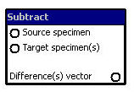

This node computes a difference vector between each of the specimens provided on the Target specimen(s) input port and the specimen provided by the Source specimen input port. The results are returned as either Warp Vectors or Specimens datatype.

p) Node: concat
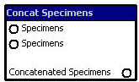
This node concatenates the specimens from the two Specimens input ports and provides the concatenated results on its Concatenated Specimens ouput port.

q) Node: transform

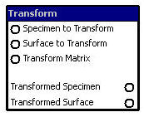

This node transforms a specimen and / or a surface given by the Specimen to Transform and Surface to Transform input ports, respectively, from one coordinate space to another. The transformation applied is provided by the node‘s Transform Matrix input port. This node places its results on its Transformed specimen and Transformed Surface output ports.

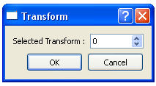

Figure 18 GUI of transform node

The GUI for this node allows the user to select which transformation matrix to use. {Note this is an example of bad design as the tranform matrix import should be a single matrix and not a vector of matrices; this will be remedied shortly.}

s) Node: R

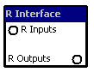

This node allows R code to be called that accepts inputs from the node‘s R Inputs import port and places the results from the R code in the node‘s R Outputs output port.

This node has a multiple input port which allows any number of other nodes to be connected to this R node. The GUI shows the symbolic names for these inputs and the R code uses these symbolic names to access the inputs. It is the called R code‘s responsibility to check that the datatypeof inputs is correct.

This node has a multiple output port which allows any number of other nodes to be connected to this R node. The R code will return a single packed value which contains in sequence the values to be transmitted to output ports to connected nodes. The connection order of other nodes to the output port will define the order in which the information returned by R is unpacked from the result returned by R. There is a runtime check to ensure that the datatype of the unpacked individual port results is compatible with the actual ports connected.

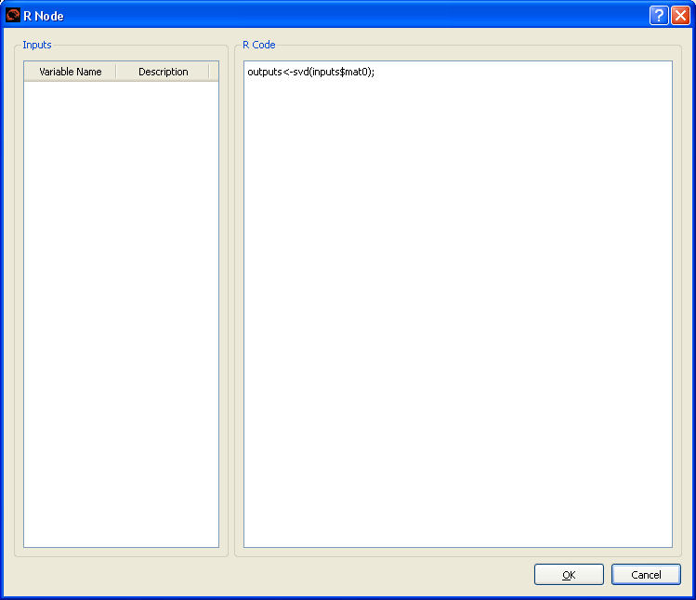
Figure 19 GUI of the R

The user provides the R code for the node in the R Code panel in the GUI.

The Inputs panel gives the symbolic names that the node has assigned to the input parameters for the R code.

